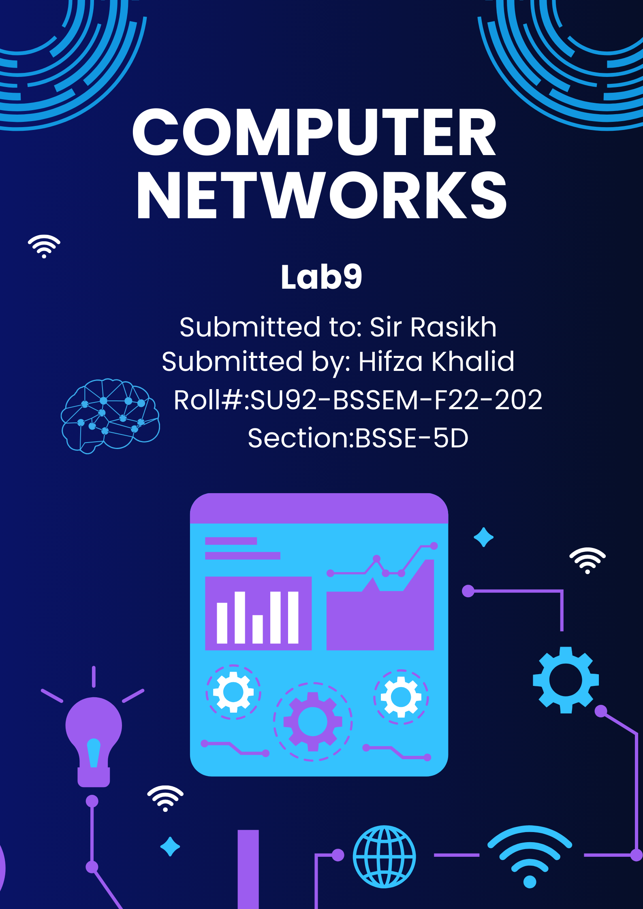

# **Lab 9 - Task**

## Task 1;

**Difference Between “Sub-Netting & Super-Netting”, with Example**

**(draw structure in cisco)**

**Subnetting** is the procedure to divide the network into sub-networks or small networks, these smaller networks are known as subnets. The [subnet](https://www.geeksforgeeks.org/introduction-to-subnetting/)is also defined as an internal address made up of a combination of a small network and host segments. In a subnet, a few bits from the host portion are used to design small-sized subnetworks from the original network. In subnetting, network bits are converted into host bits.

**Supernetting** is the procedure to combine small networks into larger spaces. In subnetting, Network addresses’ bits are increased. on the other hand, in supernetting, Host addresses’ bits are increased. Subnetting is implemented via Variable-length subnet masking, While super netting is implemented via Classless interdomain routing.

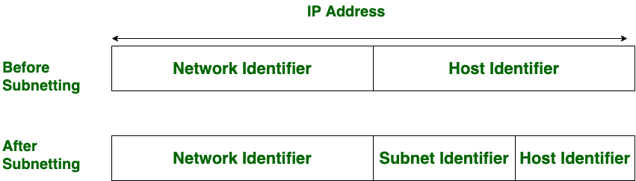

* **Subnetting and Supernetting**

|  |  |  |
| --- | --- | --- |
| ****Aspect**** | ****Subnetting**** | ****Supernetting**** |
| ****Definition**** | The process of dividing a larger network into smaller subnetworks. | The process of combining multiple smaller networks into a larger one. |
| ****Purpose**** | To optimize IP address utilization, improve security, and isolate networks. | To reduce the size of routing tables and simplify network management. |
| ****Operation**** | Splits a network by borrowing host bits for network bits. | Combines networks by borrowing network bits for host bits. |
| ****CIDR Prefix**** | Increases the prefix length (e.g., /24 → /25). | Decreases the prefix length (e.g., /24 → /23). |
| ****Example**** | Breaking 192.168.1.0/24 into two subnets: 192.168.1.0/25 and 192.168.1.128/25. | Combining 192.168.1.0/24 and 192.168.2.0/24 into 192.168.0.0/23. |
| ****Benefits**** | * Isolates traffic. | * Simplifies routing. |
|  | * Enhances security. | * Optimizes resource allocation. |

Advantages and Disadvantages of Subnetting and Supernetting

**Subnetting**

**Advantages of subnetting**

1. **Effective IP address use:** Subnetting enables the division of a large network into smaller subnets, which aids in the efficient use of IP address allocation. It lessens[IP address](https://www.geeksforgeeks.org/what-is-an-ip-address/) wastage and enables organizations to allocate IP addresses in accordance with their unique requirements.
2. Subnetting can help reduce network congestion and enhance overall network performance by breaking up a large network into smaller subnets. Smaller subnets improve the efficiency of routing and switching operations and allow for better network traffic control.
3. **Increased network security:** Subnetting makes it possible to implement security measures more precisely. Organizations can improve security by controlling access between subnets and implementing firewall rules by isolating various subnets from one another.

**Disadvantages of subnetting**

1. **Complexity:** Subnetting can make network configuration and design more complicated. It can be difficult, especially for large networks, to choose the right subnet sizes, plan IP address ranges, and manage routing between subnets.
2. Subnetting requires more administrative work, especially when adding new subnets or changing the configuration of existing ones. In addition to maintaining routing tables and ensuring proper connectivity between subnets, it entails managing IP address ranges.

* **Supernetting**

**Advantages of supernetting**

1. Supernetting enables the consolidation of several smaller networks into a single, larger network block, which reduces the size of the routing table and maximizes the use of IP address space.
2. Routing can be made easier by combining several smaller networks into a supernet because fewer routing updates and table entries are required. This may result in increased routing effectiveness and decreased router overhead.
3. A reduced number of routing lookups needed for packet forwarding thanks to supernetting can help improve network performance. As a result, packet processing may be accelerated and latency may be decreased.

* **Disadvantages of supernetting**

1. Loss of network granularity: Supernetting involves aggregating multiple networks into larger network blocks. This can result in a loss of granularity, making it more challenging to implement fine-grained network management, security policies, and traffic control.
2. Increased risk of network failures: If a single supernet experiences a network failure, it can affect multiple smaller networks within that supernet. This makes troubleshooting and isolating network issues more complex.
3. Limited flexibility: Supernetting requires careful planning and coordination to ensure that the aggregated networks have compatible address ranges. It may limit the ability to make independent changes to individual subnets within a supernet without affecting the entire supernet.

* **Structures in Cisco packet:**
* **Subnetting**

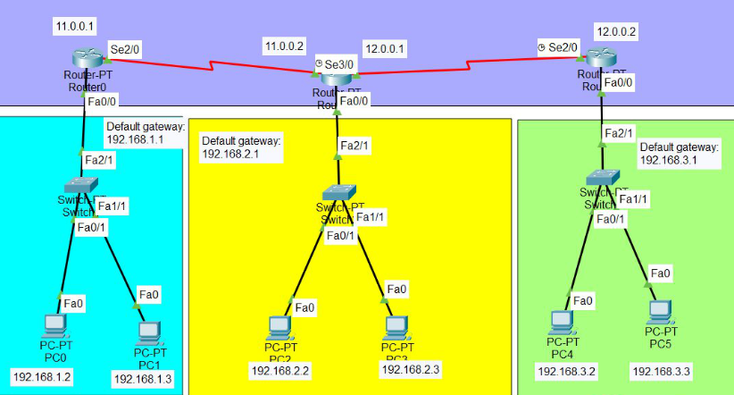

* **Supernetting**

**Conclusion**

* The terms “subnetting” and “supernetting,” which are used to divide a larger network into smaller subnetworks, have opposite meanings. However, Supernetting is used to combine a smaller range of addresses into a larger one in order to facilitate and speed up routing. These techniques are ultimately used to boost IP address availability and reduce IP address depletion.